Technical Design

Team: | Phantom | ITN: | 4 |  |  | Solution Design
 |  | Pipeline(s):
  MH7

Solution Design 1
Pipeline(s): 1
1 Introduction 1
1.1 Link to Requirements Document 1
1.2 Requirements 1
User Story 1
2 Design Discussion 2
2.1 Use Case 2
2.2 Class Diagrams 2
3 Implementation 3
3.1 Files 3
4 Testing Considerations 5
5 Screenshots 5

Introduction
This is a web-based application used to manage the contacts for a firm. The contacts are stored in a secure location on an internal server and the user is able to log in to the system using their access details.
The user can perform CRUD operations based on the privileges provided to them by the administrator.

Link to Requirements Document
https://jira2.cerner.com/browse/DEVACDMY-5165

Requirements

User Story
User Story ID | MH7
Story | Delete a person
Description | The user is able to remove persons from the collection

Design Discussion

2.1 Use Case
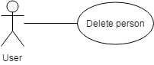

Figure 1 Use case for deleting a person

2.2 Class Diagrams

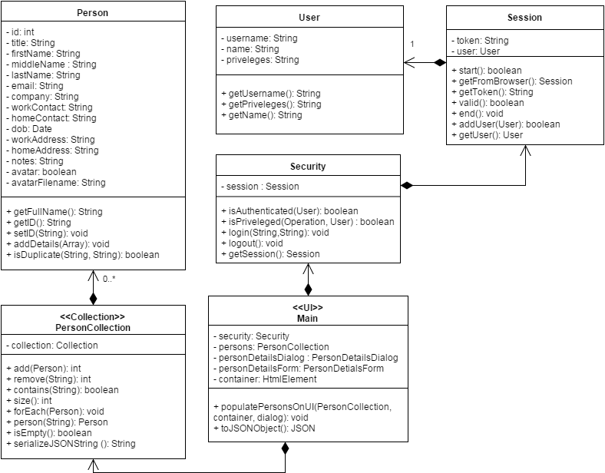

Figure 2 Class Diagram for deleting person

Implementation

The main objective is to allow the user to delete a selected person. The implementation details are as follows:
- When the user hovers the mouse over a person delete button appears on the top-right corner.
- When the user clicks on the delete button, a confirmation dialog appears asking “Are you sure?”
- Clicking on the OK button triggers the delete process. The person is removed from the collection object. The HTML box showing the person is also removed from the UI.
- Clicking the cancel button, cancels the delete procedure.

Files
3.1.1 JAVASCRIPT

File | scripts/js/Main.js
Description | This class creates the objects for the application and sets up the click and submit events. It directly deals with UI elements to implement business logic.
Pseudo Code | //setup box on delete click event  $(('#box'+id)).find('.delete').click(function(){  //get box element  var tBox = $(this).closest('.box');  // get id of clicked element  var tempid = tBox.attr('id').replace("box","");  var fullName = tBox.find('.fullName').html();  //set Message on dialog  $('#confirm-delete').html("Are you sure you want to remove '" + fullName + "' ?");  //show confirmation dialog  $('#confirm-delete').dialog({  modal: true,  height: 'auto',  width: 300,  buttons: {  OK: function(){  //remove from collection  personCollection.remove(tempid);  //remove from UI  tBox.remove();  $(this).dialog('close');  },  Cancel: function() {  $(this).dialog('close');  }  }  });  });
Passive (Yes/No) | Yes

File | scripts/js/Person.js
Description | This class is a representation of an actual person with person details defining the state and functions defining the behavior of the person.
File | scripts/js/PersonCollection.js
Description | This class is an implementation of the Collection class adapted to contain a collection of Person objects. It has methods like add(), remove(), contains(), size() etc.
File | scripts/js/User.js
Description | This class is the definition of a real-user of the application and contains user-related info like username, name, privileges etc.
File | scripts/js/Session.js
Description | This is the class that store the current session and the user associated with the session
Pseudo Code | function valid(){  request = new Request();  validateSessionEventHandler = new RequestEventHandler();  coordinator = new UICoordinator();  coordinator.sendRequest(req, validateSessionEventHandler );  if(validateSessionEventHandler.success)  return true;  else  return false;  }  }
File | scripts/js/Security.js
Description | This class is responsible for authentication and validating session and privileges. It sends a request to the server for login() and logout() respectively
Pseudo Code | function isPriveleged(operation, user){  switch(operation){  case Operation.FETCH_LIST:  case Operation.FETCH_DETAILS:  case Operation.READ:  if(user.priveleges.search('r') != -1) return true;  case Operation.ADD:  case Operation.EDIT:  case Operation.DELETE:  if(user.priveleges.search('w') != -1) return true;  default:  return false;  }  }

Testing Considerations
Navigate to the listPersons.html and follow the steps given below for each test case.

#Test Cases | Test Steps | Expected Results
TC 1 | - Click on delete button on a person box | A confirmation dialog box appears asking “Are you sure you want to remove <<fullName>> ?”
TC2 | - Click on delete button on a person box  - Click OK on the confirmation dialog | The person is removed from the UI
TC3 | - Click on delete button on a person box  - Click Cancel on the confirmation dialog | The person is not removed from the UI

Screenshots


Figure 3 Option to delete a person by clicking on the cross in the top-right corner

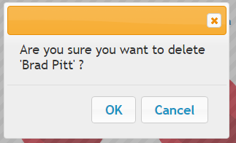
Figure 4 Confirmation dialog when deleting a person

